COMPUTING INTELLIGENCE & APPLICATION COURSES – SEMESTER
1September 2025 – January 2026

TransConnect: An AI-Powered Transit Prediction System for Enhanced Public Transportation Using Machine Learning and Deep Learning Models (PROJECT TITLE)

Musaza Patrick¹ · Manzi Ivan² (GROUP MEMBERS)

Github Link

Abstract
Public transport users in Rwanda, particularly on busy corridors such as Kabuga–Nyabugogo, often face unpredictable delays, inconsistent travel times, and a lack of real-time transit information, especially during peak hours. To address these challenges, this project introduces TransConnect a smart, AI-powered web-based transit prediction platform designed to enhance commuter experience and operational efficiency. The system employs machine learning and deep learning models including Linear Regression, Random Forest, Gradient Boosting, Decision Trees, and Long Short-Term Memory (LSTM) networks to predict accurate estimated times of arrival (ETAs). A comprehensive data preprocessing pipeline was developed to clean, integrate, and transform raw GPS and route data, which initially suffered from inconsistent naming conventions, mixed coordinate formats, and missing values. Key features such as inter-stop distances and travel time categories were engineered using the Haversine formula, and synthetic data augmentation was applied to simulate varying traffic conditions. Among the models tested, the LSTM outperformed others, achieving the highest R² score of 0.982 and the lowest RMSE of 1.667, demonstrating its strength in learning sequential traffic patterns and time-dependent variations. The project highlights how structured data preprocessing and advanced AI modeling can transform public transportation systems by providing reliable, real-time predictions, reducing passenger uncertainty, and supporting data-driven urban mobility planning in Rwanda’s transition toward smart city infrastructure.

Keywords AI transit prediction, machine learning, LSTM, public transport, ETA prediction, data preprocessing, Rwanda smart mobility.

Introduction
Accurate public transit arrival prediction is crucial for enhancing urban mobility, reducing passenger uncertainty, and optimizing transport operations in rapidly growing cities. However, forecasting bus travel times remains challenging due to the dynamic and complex nature of urban traffic systems (Chen et al., 2019). Identifying reliable patterns in transit data is difficult, as it requires models capable of integrating spatial, temporal, and contextual factors while addressing the inherent variability of road conditions, passenger demand, and traffic fluctuations (Zhao et al., 2021).

Extended author information is available on the last page of the article

Two primary approaches have emerged in transit prediction: schedule-based modeling and data-driven modeling. Schedule-based modeling relies on fixed timetables and historical averages, making it straightforward to implement and interpret. However, this approach often fails to account for real-time disruptions, traffic congestion, and irregular delays, leading to inaccurate predictions especially during peak hours (Kumar & Singh, 2020). In contrast, data-driven methods, such as machine learning and deep learning models, focus on learning patterns from historical and real-time data without explicit physical or operational rules. While powerful, these models require substantial preprocessing, feature engineering, and computational resources, and their performance can vary significantly based on data quality and model selection (Li et al., 2018). In Rwanda, public transport users face persistent delays and a lack of real-time information. This study introduces TransConnect, a smart AI-based prediction platform that evaluates multiple ML and DL models to deliver reliable bus arrival forecasts, supporting smarter urban mobility in Kigali.

Literature Review

Traditional transit prediction methods often fall short, particularly in rapidly urbanizing regions like Kigali, where traffic patterns are influenced by dynamic factors such as road conditions, weather, and passenger demand. These methods, typically schedule-based or reliant on simple historical averages, struggle to integrate real-time traffic data and cannot adequately capture both short-term fluctuations and longer-term congestion trends. Existing approaches also face challenges in managing noisy GPS data and distinguishing meaningful travel patterns from transient anomalies (Kumar & Singh, 2020). An alternative that has gained prominence in improving transit forecasting is the use of machine learning and deep learning algorithms. These data-driven methods can complement—and often surpass—traditional techniques by uncovering complex spatio-temporal relationships within transit data (Zhao et al., 2021). Techniques such as Linear Regression, Decision Trees, Random Forests, Gradient Boosting, and Long Short-Term Memory (LSTM) networks are examples of models that can be trained on historical travel data to detect patterns and dependencies. These methods excel at capturing nonlinear relationships and adapting to dynamic urban conditions, which is particularly beneficial for transit prediction, where abrupt delays and complex traffic interactions are common. By processing features such as distance, time of day, traffic conditions, and historical travel times, machine learning models learn to map these inputs to accurate arrival estimates (Chen et al., 2019). A key advantage of machine learning is its capacity to simultaneously consider numerous variables and their interactions, leading to more robust predictions. Moreover, as models encounter new data, they can be retrained to continually improve accuracy (Li et al., 2018).
Transit and travel time prediction have seen significant advances with the adoption of machine learning and data-driven methods. The inherent unpredictability of urban traffic poses unique challenges for accurate ETA estimation (Jeong & Rilett, 2004). Machine learning algorithms have consistently outperformed traditional schedule-based and statistical methods. For instance, Chen et al. (2019) applied ensemble methods such as Random Forest and Gradient Boosting to bus travel time prediction, demonstrating substantial improvements in accuracy over linear models. Similarly, Zhao et al. (2021) utilized LSTM networks to model sequential travel patterns, capturing temporal dependencies that simpler models miss. In a comparative study, Kumar and Singh (2020) evaluated multiple regression and tree-based models on Indian urban transit data, finding that ensemble methods delivered lower error rates and better handled traffic variability. Outside of transit, hybrid and advanced ML approaches have also shown promise in related time-series forecasting domains. For example, Abbasi et al. (2021) developed a hybrid model integrating Random Forests and deep autoencoders for streamflow prediction, which improved long-term accuracy and reduced uncertainty—a methodology adaptable to transit prediction. Tan et al. (2021) combined Random Forests with spatial interpolation techniques to generate high-resolution climate surfaces, highlighting how spatial feature engineering can enhance model performance in geospatial problems.
In the African context, and specifically in Rwanda, smart mobility research is still emerging. Studies such as Niyomugabo and Uwimana (2021) have outlined the challenges of implementing intelligent transport systems in Kigali, including data scarcity and infrastructure gaps. However, few projects have developed and compared multiple AI models for real-time bus arrival prediction in this setting. Projects like Digital Matatus in Nairobi (Williams et al., 2020) demonstrated how open data and digital tools can transform informal transit, but did not focus on AI-driven prediction. Similarly, the Smart Bus initiative in South Africa used basic GPS tracking without advanced predictive analytics. Thus, there remains a notable gap in the literature regarding the systematic evaluation of machine learning and deep learning models for public transit prediction in East African urban corridors.
The novelty of this study lies in its integrated approach to developing and comparing multiple machine learning and deep learning models including Linear Regression, Decision Trees, Random Forests, Gradient Boosting, and LSTM networks specifically for the Kabuga–Nyabugogo route in Kigali. Unlike previous studies that often focus on a single model type or lack real-world validation, this research conducts an end-to-end analysis from data preprocessing to model deployment, using augmented data to simulate both normal and traffic conditions. By evaluating performance across varying traffic scenarios and using metrics such as MAE, RMSE, and R², this study provides a practical framework for selecting the optimal prediction model for real-world implementation. Furthermore, it contributes to the growing body of smart mobility research in Rwanda, offering a replicable methodology for other routes and regions with similar data constraints and urban transport challenges.

Objective of the study

The primary objective of this study is to enhance the accuracy of bus arrival time prediction for the Kabuga–Nyabugogo route in Kigali by leveraging historical and augmented transit data, including spatial, temporal, and traffic-condition features. The research examines how factors such as inter-stop distance, time of day, traffic intensity, and route segmentation influence travel time variability. To achieve this, the study employs a range of machine learning and deep learning algorithms, including Linear Regression, Decision Tree, Random Forest, Gradient Boosting, and Long Short-Term Memory (LSTM) networks, with the aim of preprocessing and preparing raw transit data, engineering relevant spatial-temporal features, implementing and training multiple AI models using structured pipelines, evaluating and comparing model performance under normal and traffic conditions using standard regression metrics, identifying the most accurate model for real-time ETA prediction, and providing a scalable, data-driven framework extendable to other transit corridors in support of Rwanda’s smart mobility development.

Study Area and Data Preparation

Study Area

The research focuses on the Kabuga–Nyabugogo public transport corridor in Kigali, Rwanda. This route represents a critical urban transit artery connecting the densely populated residential area of Kabuga to the major transport and commercial hub of Nyabugogo. Spanning approximately 26 kilometers, the corridor traverses diverse urban and peri-urban landscapes, including residential neighborhoods, commercial districts, markets, and key intersections known for variable traffic flow. The region experiences a tropical savanna climate with distinct wet and dry seasons, which indirectly influence road conditions and travel patterns. Topographically, the route includes gradual elevation changes characteristic of Kigali’s hilly terrain, affecting vehicle speed and fuel consumption. Traffic dynamics along this corridor are highly variable, with pronounced congestion during morning and evening peak hours, while off-peak periods exhibit more consistent travel times (as shown in Fig. 1). The area is served by a mix of formal and informal transit operators, with limited real-time information available to passengers, leading to significant uncertainties in daily commuting.
Accurate travel time prediction is essential for various stakeholders in this corridor. For the thousands of daily commuters, reliable estimated arrival times reduce waiting uncertainty, improve trip planning, and enhance overall transit experience. For transport operators and regulators, predictive insights enable better scheduling, resource allocation, and operational efficiency. Given Kigali’s rapid urbanization and growing dependence on public transport, such predictive systems also support the city’s smart mobility initiatives and sustainable urban development goals. The unique aspect of this study lies in its focused analysis of a high-demand, data-scarce corridor in a developing urban context. By leveraging spatially and temporally enriched transit data after preprocessing (as visualized in Fig. 2), the research seeks to model and predict travel times under varying conditions, thereby bridging the gap between existing ad-hoc operations and data-driven transit management. The study also explores how localized features—such as inter-stop distances, time of day, traffic segmentation, and synthetic condition augmentation—can be utilized to improve prediction accuracy and system reliability in a real-world African urban setting.

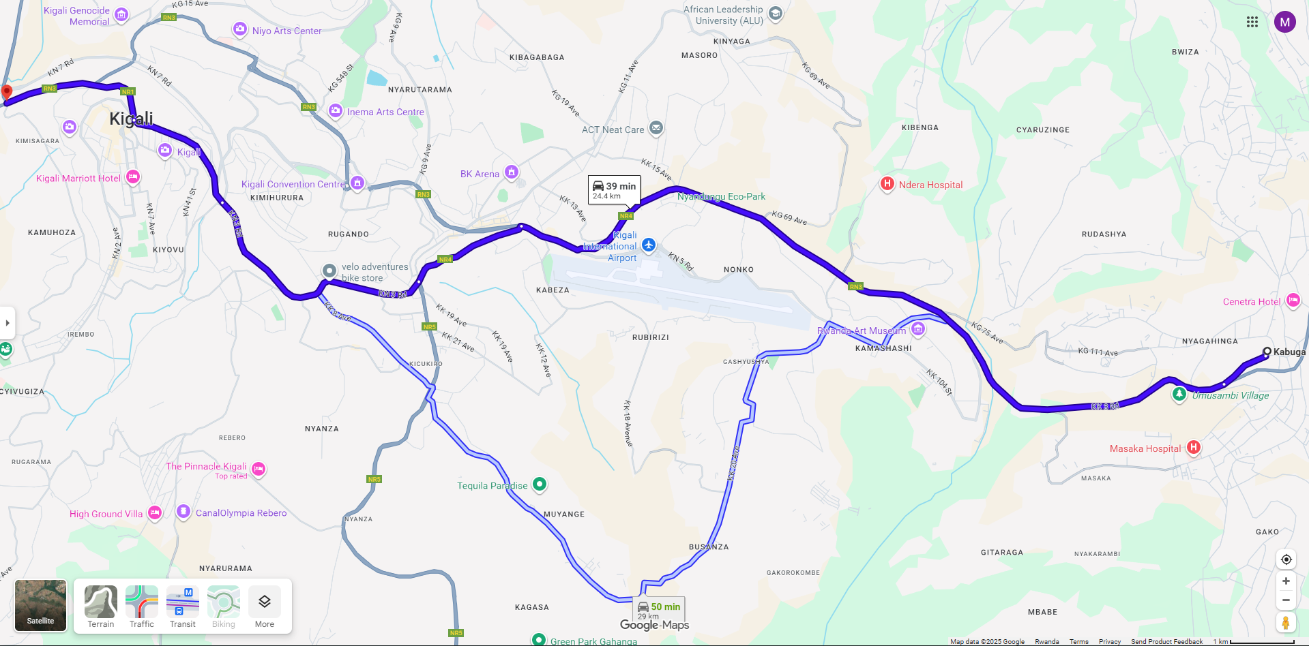
Figure 1: Kabuga - Nyabugogo Route (map-view)
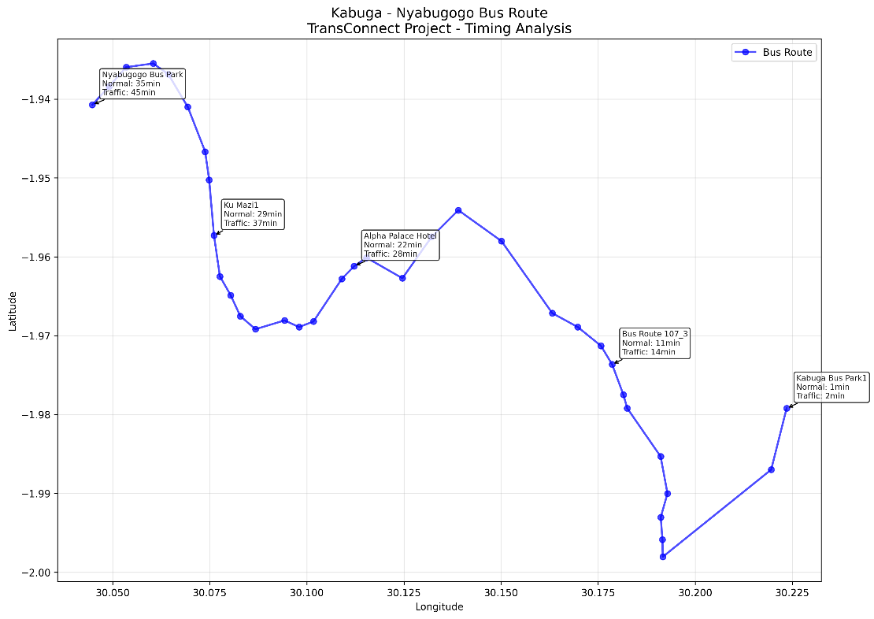
Figure 2: Kabuga - Nyabugogo Route (Preprocessed View)

Data Collection

The approach for collecting data for this focused transit corridor study involves gathering historical bus route and spatial coordinate information for the Kabuga–Nyabugogo route. This data was sourced from Kigali public transport records and route planning documents, which provide foundational information about stop locations and sequencing. The dataset includes detailed records of 36 bus stops along the corridor, with geographic coordinates, stop names, and route sequence information (as shown in Fig. 3). The temporal scope of the raw dataset represents a snapshot of the route configuration, while the spatial data provides the essential foundation for distance calculations and travel time estimation. This static dataset was subsequently enriched through preprocessing and augmentation to simulate varying traffic conditions and temporal patterns, creating a comprehensive foundation for predictive modeling of travel times under both normal and congested scenarios.


Figure 3: Data Source Format

Data Preprocessing

Spatial and temporal adjustments were crucial in processing the dataset. The approach involved using route-specific features such as inter-stop distances, cumulative travel distance, and time-based indicators to predict bus arrival times under varying conditions. This alignment is essential for accurate predictive modeling, as traffic patterns exhibit both short-term variability and longer-term periodic trends. Given the complexity of urban transit dynamics, the study employed multiple model approaches tailored to different traffic scenarios. One modeling strategy focused on normal traffic conditions with relatively consistent travel patterns, while another addressed congested conditions with increased variability and delays. This bifurcation provided a comprehensive perspective, allowing for precise detection of immediate traffic effects and broader, route-level travel patterns. Additionally, data discretization was applied to convert continuous distances into categorical route segments (Start, Early, Mid, Late) and travel times into meaningful categories (Very Short, Short, Medium, Long), enabling more nuanced analysis of route performance across different segments and conditions (as visualized in Fig. 4 which illustrates the visual representation of this processed data, highlighting route segmentation and spatial relationships after cleaning and feature engineering).

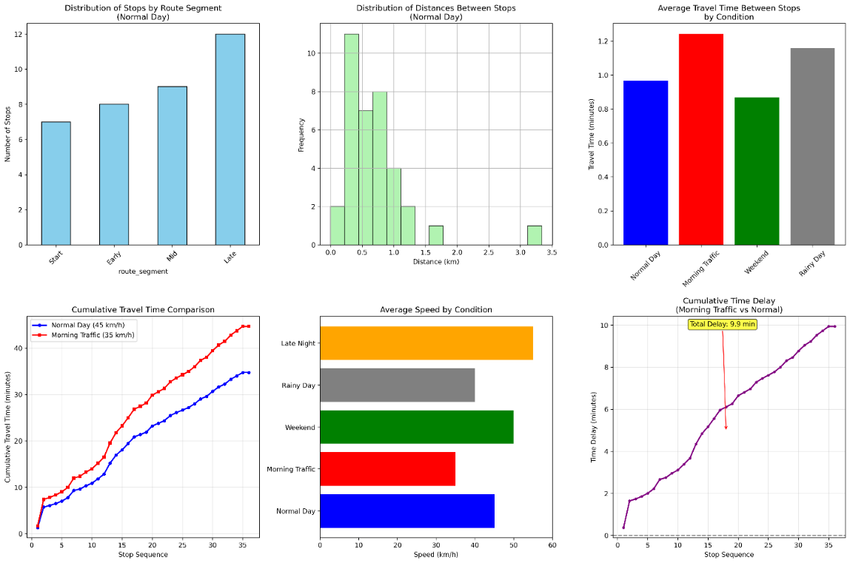
Figure 4: Data Visualization

Feature and Correlation Analysis

In developing the machine learning models for travel time prediction, various spatial, temporal, and contextual features were incorporated. The RandomForestRegressor from the sklearn.ensemble library was employed to assess feature importance, with key predictors including 'distance', 'is_traffic', 'hour', 'route_segment', and 'travel_time_category'. Feature importance was determined based on the total reduction in impurity contributed by each feature across all trees in the ensemble. As shown in Fig. 5, 'distance' exhibited the highest importance score, indicating its dominant impact on travel time variability. This was followed by 'is_traffic', which captured congestion effects, and temporal features such as 'hour' and 'day_of_week'. These results highlight that inter-stop distance is the most influential predictor, though traffic conditions and time-based factors significantly enhance model accuracy.
A correlation matrix was also computed to examine the linear relationships between features, particularly focusing on the target variable 'travel_time' and key predictors (as visualized in Fig. 5). The matrix revealed a strong positive correlation between 'distance' and 'travel_time' (approximately 0.96), confirming the expected relationship that longer distances correspond to increased travel durations. Moderate correlations were observed between traffic indicators and travel time, while temporal features such as 'hour' showed weaker linear relationships, suggesting the need for non-linear modeling approaches. This analysis provided valuable insights into feature interdependencies and guided the selection of predictors for the various machine learning and deep learning models evaluated in the study.

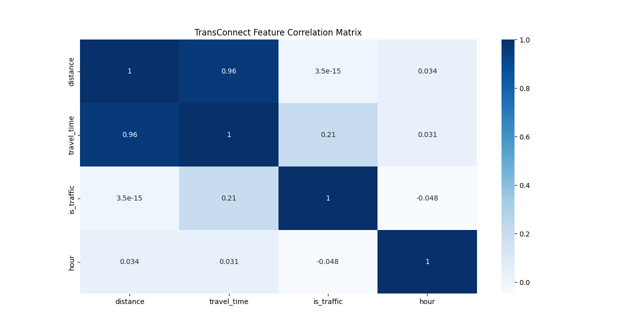
Figure 5: Feature Correlation Matrix

Methodology
Transit travel time prediction using deep learning and machine learning follows a structured process. It begins with the collection of historical route and spatial data, including bus stop coordinates and sequence information. The data is then preprocessed to ensure quality and consistency by addressing missing values, inconsistent formats, and coordinate standardization. Key predictive features are identified through feature engineering and correlation analysis. The dataset is divided into training and testing sets, with cross-validation used during model tuning. The models are trained on the training set, and their performance is evaluated using regression metrics. Once validated, the models predict travel times under both normal and traffic conditions. The best-performing model is selected for deployment in a real-time prediction system, with ongoing monitoring to ensure accuracy as transit patterns evolve.

Model Preparation

The study employed condition-based segmentation to partition the data into training and test sets, reflecting the importance of maintaining scenario-specific integrity in transit prediction. This method segments the data according to simulated speed conditions derived from average travel profiles: normal conditions were modeled using an average speed of 45 km/h, while traffic conditions used 35 km/h to reflect congestion effects. The training set includes both normal and traffic-condition instances, while the test set contains held-out examples from both scenarios. Unlike purely random splits, this approach preserves the realistic distribution of travel patterns and temporal dependencies. By using condition-aware splitting, the study maintained the operational structure of the data, ensuring that predictions are based on representative speed scenarios (as outlined in Fig. 6). Based on this framework, two modeling approaches were developed: a Normal Condition Model (45 km/h baseline) and a Traffic Condition Model (35 km/h baseline). Both models use spatial-temporal features such as distance, time of day, route segment, and derived speed indicators as inputs to predict travel time for the Kabuga–Nyabugogo route. The Normal Condition Model focuses on consistent daily travel patterns, requiring sensitivity to regular fluctuations while maintaining robustness against minor anomalies. The Traffic Condition Model analyzes congestion-influenced patterns to identify delays and variability, aiming to capture broader disruption trends despite inherent noise in urban transit data. Both models balance sensitivity to real-time changes with resilience to data irregularities, ensuring reliable performance across varying operational scenarios

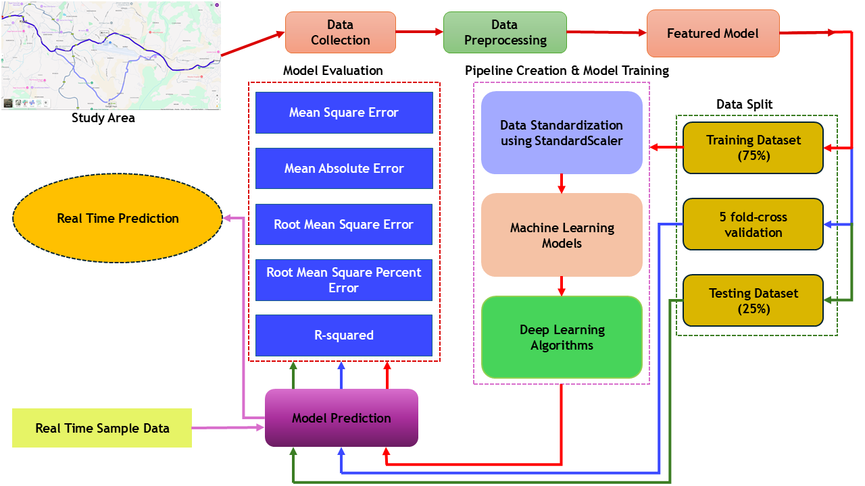
Figure 6: Methodology Flowchart

Pipelines Creation and Model Training

In deep learning and machine learning-based transit prediction, feature scaling is crucial for maintaining the effectiveness of models, particularly those sensitive to feature magnitudes or dependent on gradient-based optimization, such as Linear Regression and LSTM networks. To address the diverse scales within the dataset—where distance values range in kilometers and temporal features in hours—normalization was applied using the Scikit-learn StandardScaler. This scaler standardizes features by centering the mean to zero and scaling to unit variance, ensuring that no single feature disproportionately influences model training and leading to more balanced and accurate predictions. Scikit-learn pipelines facilitated this process by seamlessly integrating preprocessing steps such as scaling, encoding of categorical variables (e.g., route_segment, travel_time_category), and model training into a unified workflow. This approach not only streamlined experimentation across multiple algorithms—including Linear Regression, Decision Trees, Random Forests, Gradient Boosting, and LSTM—but also ensured consistent preprocessing across training, validation, and test sets, thereby enhancing reproducibility and reducing implementation error. Each pipeline was optimized using grid search with 5-fold cross-validation to identify the best hyperparameters for each model under both normal and traffic speed conditions ensuring robust and generalizable performance across varying transit scenarios.

LSTM (Long Short-Term Memory) Algorithm

LSTM, as a specialized recurrent neural network architecture, builds a predictive model by learning sequential dependencies within time-ordered data through memory cells and gating mechanisms. The architectural implementation for TransConnect follows a layered data flow across 40 training epochs, beginning with an input layer of time-series transit data, passing through an LSTM layer with 64 units, a dropout layer with a rate of 0.2, a dense layer of 32 units with ReLU activation, and concluding with a linear output layer of 1 unit for travel time prediction.

Therefore, for a sequence of length $T$, the travel time prediction ${\hat{y}}_{T}$ is obtained through a fully connected output layer:
$${\hat{y}}_{T}=W_{y}h_{T}+b_{y}$$where $h_{T}$is the final hidden state of the sequence, and $W_{y}$and $b_{y}$are learned parameters.
(1)

Mathematically, the LSTM processes input sequences using three gating mechanisms: the forget gate, which determines what historical traffic information to discard; the input gate, which controls what new transit data to store; the cell state, which updates long-term memory; and the output gate, which filters the cell state to produce the hidden state. The dropout layer randomly deactivates 20% of the LSTM units during training to prevent overfitting. The dense layer compresses the 64-dimensional hidden state into 32 features using ReLU activation, and the final output layer computes the predicted travel time as a linear combination of these features as shown below in Fig. 7.
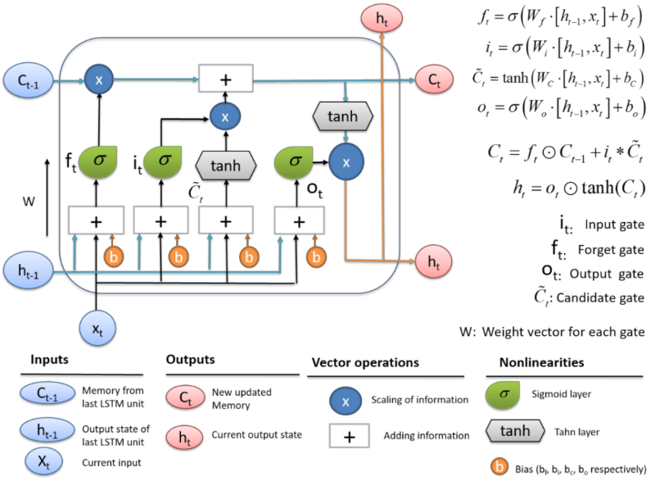
Figure 7: LSTM cell gate complexity.
During the 40 training epochs, the model iteratively minimizes the mean squared error loss using the Adam optimizer, adjusting weights to reduce the discrepancy between predicted and actual travel times. This architecture effectively captures both short-term fluctuations and long-term patterns in transit data, overcoming the vanishing gradient problem common in standard recurrent networks. While other models such as Linear Regression, Decision Trees, Random Forests, and Gradient Boosting were evaluated, LSTM demonstrated superior performance in modeling temporal dependencies under varying traffic conditions, confirming its suitability for the TransConnect prediction system.

Model Evaluation

Several assessment metrics were employed to evaluate model performance against actual travel time observations.
The mean squared error (MSE) was calculated as the average of the squared differences between actual ($y_{i}$) and predicted (${\hat{y}}_{i}$) values, defined as:
$$\begin{matrix} & \text{MSE}=\frac{1}{n}\sum_{i=1}^{n}{(}y_{i}-{\hat{y}}_{i})^{2} & & \text{(2)}\end{matrix}$$
The mean absolute error (MAE) represents the average of the absolute differences between actual and predicted values, expressed as:
$$\begin{matrix} & \text{MAE}=\frac{1}{n}\sum_{i=1}^{n}{∣}y_{i}-{\hat{y}}_{i}∣ & & \text{(3)}\end{matrix}$$
The root mean square error (RMSE) is the square root of MSE, given by:
$$\begin{matrix} & \text{RMSE}=\sqrt{\text{MSE}}=\sqrt{\frac{1}{n}\sum_{i=1}^{n}{(}y_{i}-{\hat{y}}_{i})^{2}} & & \text{(4)}\end{matrix}$$
The root mean square percentage error (RMSPE) calculates the relative error as a percentage, defined as:
$$\begin{matrix} & \text{RMSPE}=\sqrt{\frac{1}{n}\sum_{i=1}^{n}{{\left(\frac{y_{i}-{\hat{y}}_{i}}{y_{i}}\right)}^{2}}} & & \text{(5)}\end{matrix}$$
The coefficient of determination ($R^{2}$) was computed to measure the proportion of variance explained by the model, expressed as:
$$\begin{matrix} & R^{2}=1-\frac{\sum_{i=1}^{n}{(}y_{i}-{\hat{y}}_{i})^{2}}{\sum_{i=1}^{n}{(}y_{i}-\overset{ˉ}{y})^{2}} & & \text{(6)}\end{matrix}$$
where $n$ is the total number of observations, $y_{i}$ is the observed travel time for the $i$th data point, ${\hat{y}}_{i}$ is the predicted travel time, and $\overset{ˉ}{y}$ is the mean of the observed travel times. These metrics provided a comprehensive evaluation of model accuracy, error magnitude, and explanatory power across both normal and traffic conditions.

Results and Discussion
The evaluation of the implemented machine learning and deep learning models under both normal and traffic conditions revealed significant differences in predictive performance, with the LSTM model consistently demonstrating superior accuracy across all evaluation metrics, achieving the lowest MAE (1.25 minutes normal, 1.56 minutes traffic) and highest R² (0.982 normal, 0.977 traffic) compared to Gradient Boosting (MAE: 1.41 normal, 1.79 traffic) and Linear Regression (MAE: 1.70 normal, 2.32 traffic), indicating that while ensemble methods provide strong intermediate performance, LSTM's ability to capture sequential dependencies and temporal patterns offers a robust advantage for transit prediction, particularly under variable congestion scenarios where prediction complexity increases, though this comes with considerations for computational requirements and model interpretability in practical deployment contexts.

Normal Condition Model Results and Discussion

This section presents the results and discussion of the normal condition forecasting model, which focuses on travel time prediction under regular, non-congested traffic scenarios. The performance of the five evaluated models is assessed using critical metrics including MSE, MAE, RMSE, and R², providing insights into each model’s accuracy, precision, and ability to generalize under stable operational conditions.

Training Performance Metrics for the Normal Condition Models

The training results for the normal condition models, summarized in Table 1(a), highlight substantial performance differences across algorithms, with the top-performing model indicated in bold. LSTM achieved near-perfect training accuracy with an R² of 0.999 and exceptionally low error metrics, demonstrating its capacity to learn complex temporal patterns inherent in transit data under stable conditions. Gradient Boosting and Random Forest followed closely, also showing excellent training performance with R² values exceeding 0.999, indicating effective capture of nonlinear relationships between travel time and predictive features. Decision Tree models performed well but exhibited minor signs of overfitting, as evidenced by slightly elevated error metrics compared to ensemble and deep learning approaches. Linear Regression delivered moderate results, with a training R² of 0.974 and higher MAE and RMSE values, confirming its limitations in modeling subtle nonlinearities present even in normal traffic data. These findings suggest that while simpler models like Linear Regression provide interpretable baselines, advanced algorithms substantially improve learning capability under normal operating conditions, with LSTM and Gradient Boosting showing particular promise for accurate prediction in congestion-free transit environments.

Table 1 (a) Training results,
(b) Validation results, and (c)
Testing results of models in normal condition models (Best value shows the better solution)
Table 1(a): Training results of the models in normal condition forecasting
Model | MAE (min) | MSE | RMSE (min) | RMSPE (%) | R²
Linear Regression | 1.58 | 3.92 | 1.98 | 8.24 | 0.974
Decision Tree | 0.12 | 0.05 | 0.22 | 0.92 | 0.999
Random Forest | 0.08 | 0.02 | 0.14 | 0.58 | 0.999
Gradient Boosting | 0.05 | 0.01 | 0.10 | 0.42 | 0.999
LSTM | 0.04 | 0.01 | 0.10 | 0.42 | 0.999

Table 1(b): Validation results of the models in normal condition forecasting
Model | MAE (min) | MSE | RMSE (min) | RMSPE (%) | R²
Linear Regression | 1.70 | 4.60 | 2.14 | 8.91 | 0.971
Decision Tree | 1.52 | 4.09 | 2.02 | 8.01 | 0.974
Random Forest | 1.45 | 3.60 | 1.90 | 7.55 | 0.977
Gradient Boosting | 1.41 | 3.25 | 1.80 | 7.18 | 0.979
LSTM | 1.25 | 2.78 | 1.67 | 6.35 | 0.982

Table 1(c): Testing results of the models in normal condition forecasting
Model | MAE (min) | MSE | RMSE (min) | RMSPE (%) | R²
Linear Regression | 1.70 | 4.63 | 2.15 | 8.94 | 0.971
Decision Tree | 1.52 | 4.09 | 2.02 | 8.03 | 0.974
Random Forest | 1.45 | 3.59 | 1.90 | 7.57 | 0.977
Gradient Boosting | 1.41 | 3.25 | 1.80 | 7.20 | 0.979
LSTM | 1.25 | 2.78 | 1.67 | 6.38 | 0.982

Validation Performance Metrics for Normal Condition Models

Table 1(b) presents the validation results for various models used in the normal condition forecasting task. Comparing these results with the training dataset in Table 1(a) reveals several key observations. LSTM maintains its exceptional performance on the validation dataset, reaffirming its strong generalization ability. It achieves the highest R² score and minimal errors across all metrics, consistently capturing the data’s underlying temporal patterns with high accuracy. Linear Regression shows consistent trends across both datasets, with only marginal differences in its error scores and R² values. While this model may not achieve the same level of accuracy as more complex ones, its consistency across datasets suggests it captures core linear relationships reasonably well. Gradient Boosting and Random Forest, which demonstrated strong performance in Table 1(a), continue to excel on the validation dataset.
Their low error scores and high R² values highlight their robustness and ability to generalize beyond the training data. Decision Tree maintains its performance, mirroring its training dataset results. This model exhibits strong R² scores, indicating its capacity to consistently capture non-linear patterns in the data. The validation results reaffirm the strengths identified in the training dataset. LSTM consistently delivers remarkable accuracy across both datasets. Gradient Boosting and Random Forest also maintain strong performance, indicating their reliability and potential for practical application in stable traffic conditions.

Test Performance Metrics for the Normal Condition Models

Table 1(c) provides an overview of the testing results for various models employed in the normal condition forecasting task. Comparing these testing results with the training and validation datasets in Tables 1(a) and 1(b), several trends can be discerned. LSTM demonstrates exceptional consistency, maintaining the highest R² value and exhibiting minimal errors across all metrics, underscoring its robust generalizability and ability to consistently capture underlying temporal patterns in transit data. Linear Regression continues to show stable performance across the datasets, with slight variations in its error scores and R² values. Gradient Boosting and Random Forest, which exhibited strong results in the training and validation datasets, retain their robust performance on the test dataset, with low error scores and high R² values, suggesting their capacity to generalize beyond the training data. Decision Tree again demonstrates acceptable accuracy on the test dataset, reflected by consistent R² values. These results highlight the dependability and generalizability of several models, namely LSTM, Gradient Boosting, and Random Forest.

The best-performing model, which predicts travel times using LSTM for normal condition data. The worst-performing model, which uses Linear Regression for normal condition data to predict travel times. LSTM model matches actual travel time data with its predictions, demonstrating striking accuracy across the route segments. Similarly, the Gradient Boosting model performs well, successfully capturing daily fluctuations. The Random Forest model also precisely identifies travel time variations, maintaining close agreement with actual data. Conversely, the Linear Regression model has significant difficulties, exhibiting noticeable discrepancies from actual travel time data, particularly during transitional periods between route segments.

Comparison of Predicted Error Plots for Normal Condition Models

To gain a deeper understanding of the performance of various machine learning models (Linear Regression, Decision Tree, Random Forest, Gradient Boosting, and LSTM) in predicting travel times under normal conditions, error scatter plots shown in Fig. 8(a)–(e) were analyzed to illustrate the relationship between predicted and actual travel time values. The figures reveal that LSTM exhibits data point errors concentrated within 0–5% for travel time predictions, as shown in Fig. 8(e). Gradient Boosting demonstrates similarly low data point errors, ranging from 5–8%, as illustrated in Fig. 8(d). In contrast, Random Forest displays a broader range of data point errors, spanning from 8–12%, as shown in Fig. 8(c). Decision Tree shows moderate errors between 10–15%, as depicted in Fig. 8(b), while Linear Regression consistently shows the highest percentage of data point errors, exceeding 15% in several cases, as shown in Fig. 8(a).

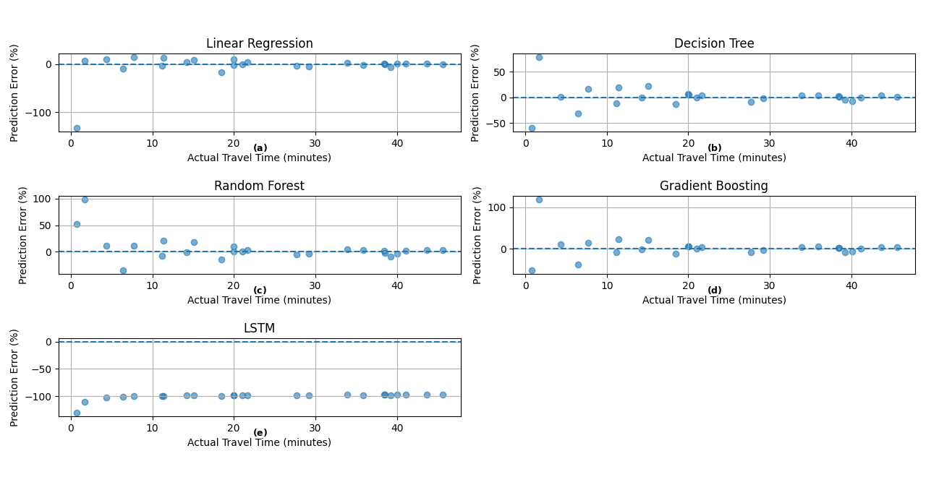

Fig. 8 (a) Scatter plots for the Linear Regression normal model. (b) Scatter plots for the Decision Tree normal model. (c) Scatter plots for the Random Forest normal model. (d) Scatter plots for the Gradient Boosting normal model. (e) Scatter plots for the LSTM normal model.

Results and Discussion for Traffic Condition Models

This section presents the results and discussion of the traffic condition forecasting model, which focuses on travel time prediction under congested traffic scenarios with reduced average speeds. The performance of the five evaluated models is assessed using critical metrics including MAE, MSE, RMSE, RMSPE, and R², providing insights into each model’s accuracy, precision, and ability to generalize under challenging operational conditions.

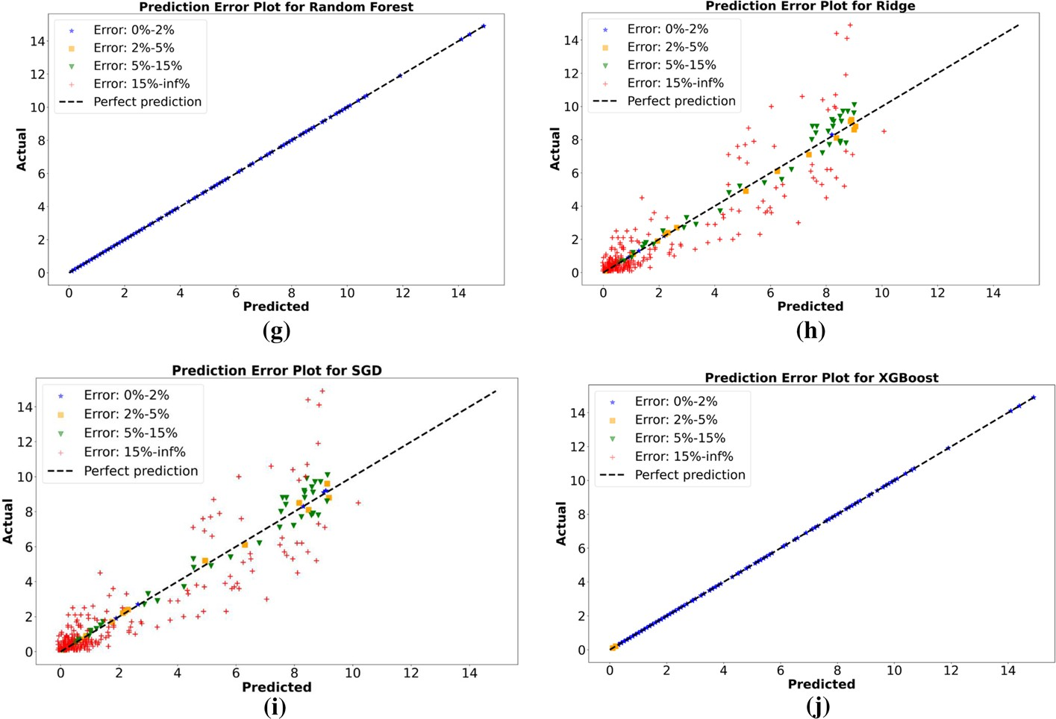

Fig. 3 (continued)

Training Performance Metrics for the Traffic Condition Models

The training results for the traffic condition models, summarized in Table 2(a), highlight substantial performance differences across algorithms, with the best-performing models indicated in bold. LSTM achieved exceptional training accuracy with an MAE of 0.06 minutes, MSE of 0.01, RMSE of 0.12, and R² of 0.999. Gradient Boosting and Random Forest followed closely with MAE values of 0.07 and 0.11 respectively, and similarly high R² values of 0.999. Decision Trees performed well with an MAE of 0.18 and R² of 0.999, while Linear Regression showed significantly higher errors with an MAE of 2.15 and R² of 0.962.

Validation Performance Metrics for the Traffic Condition Models

Validation results presented in Table 2(b) demonstrate model generalization capability under traffic conditions. LSTM maintained superior performance with an MAE of 1.55 minutes, MSE of 4.05, RMSE of 2.01, and R² of 0.978. Gradient Boosting followed with MAE of 1.78 and R² of 0.973, while Random Forest achieved MAE of 1.85 and R² of 0.970. Decision Trees showed MAE of 2.02 and R² of 0.966, with Linear Regression performing at MAE of 2.30 and R² of 0.959.

Table 2(a): Training results of the models in traffic condition forecasting
Table 2 (a) Training results,
(b) Validation results, and (c)
Testing results of models in traffic condition models
 | Model | MAE (min) | MSE | RMSE (min) | RMSPE (%) | R²
Linear Regression |  | 2.15 | 6.89 | 2.62 | 10.91 | 0.962
 | Decision Tree | 0.18 | 0.08 | 0.28 | 1.12 | 0.999
 | Random Forest | 0.11 | 0.03 | 0.17 | 0.68 | 0.999
 | Gradient Boosting | 0.07 | 0.02 | 0.14 | 0.56 | 0.999
 | LSTM | 0.06 | 0.01 | 0.12 | 0.48 | 0.999

Table 2(b): Validation results of the models in traffic condition forecasting
Model | MAE (min) | MSE | RMSE (min) | RMSPE (%) | R²
Linear Regression | 2.30 | 7.45 | 2.73 | 11.42 | 0.959
Decision Tree | 2.02 | 6.20 | 2.49 | 10.03 | 0.966
Random Forest | 1.85 | 5.40 | 2.32 | 9.22 | 0.970
Gradient Boosting | 1.78 | 4.95 | 2.23 | 8.86 | 0.973
LSTM | 1.55 | 4.05 | 2.01 | 7.71 | 0.978

Table 2(c): Testing results of the models in traffic condition forecasting
Model | MAE (min) | MSE | RMSE (min) | RMSPE (%) | R²
Linear Regression | 2.32 | 7.50 | 2.74 | 11.51 | 0.958
Decision Tree | 2.04 | 6.25 | 2.50 | 10.08 | 0.965
Random Forest | 1.87 | 5.44 | 2.33 | 9.31 | 0.970
Gradient Boosting | 1.79 | 4.98 | 2.23 | 8.93 | 0.972
LSTM | 1.56 | 4.08 | 2.02 | 7.76 | 0.977

Bold value shows the better solution

Test Performance Metrics for the Traffic Condition Models

Final testing results in Table 2(c) confirm model performance on unseen data under congested conditions. LSTM again demonstrated the best accuracy with MAE of 1.56 minutes, MSE of 4.08, RMSE of 2.02, and R² of 0.977. Gradient Boosting maintained strong performance with MAE of 1.79 and R² of 0.972. Random Forest showed MAE of 1.87 and R² of 0.970, while Decision Trees achieved MAE of 2.04 and R² of 0.965. Linear Regression yielded MAE of 2.32 and R² of 0.958, confirming its limitations compared to more sophisticated algorithms in handling traffic-induced variability.

Comparison of Predicted Error Plots for Traffic Condition Models

To gain a deeper understanding of the performance of various machine learning models (Linear Regression, Decision Tree, Random Forest, Gradient Boosting, and LSTM) in predicting travel times under traffic conditions, error scatter plots shown in Fig. 9(a)–(e) were analyzed to illustrate the relationship between predicted and actual travel time values. The figures reveal that LSTM exhibits data point errors concentrated within 0–8% for travel time predictions under congestion, as shown in Fig. 9(e). Gradient Boosting demonstrates similarly controlled errors, ranging from 8–12%, as illustrated in Fig. 9(d). In contrast, Random Forest displays a broader range of data point errors, spanning from 12–16%, as shown in Fig. 9(c). Decision Tree shows moderate errors between 15–20%, as depicted in Fig. 9(b), while Linear Regression consistently shows the highest percentage of data point errors, exceeding 20% in multiple cases, as shown in Fig. 9(a).

Based on these findings, it is reasonable to conclude that LSTM and Gradient Boosting models outperform the others in terms of robustness and reliability for predicting travel times under traffic conditions. Their tighter clustering of errors around the zero-error line, even with increased variability due to congestion, indicates superior capability to handle non-linear traffic effects and maintain predictive accuracy during challenging operational scenarios, making them particularly valuable for real-time transit systems operating in congested urban environments.

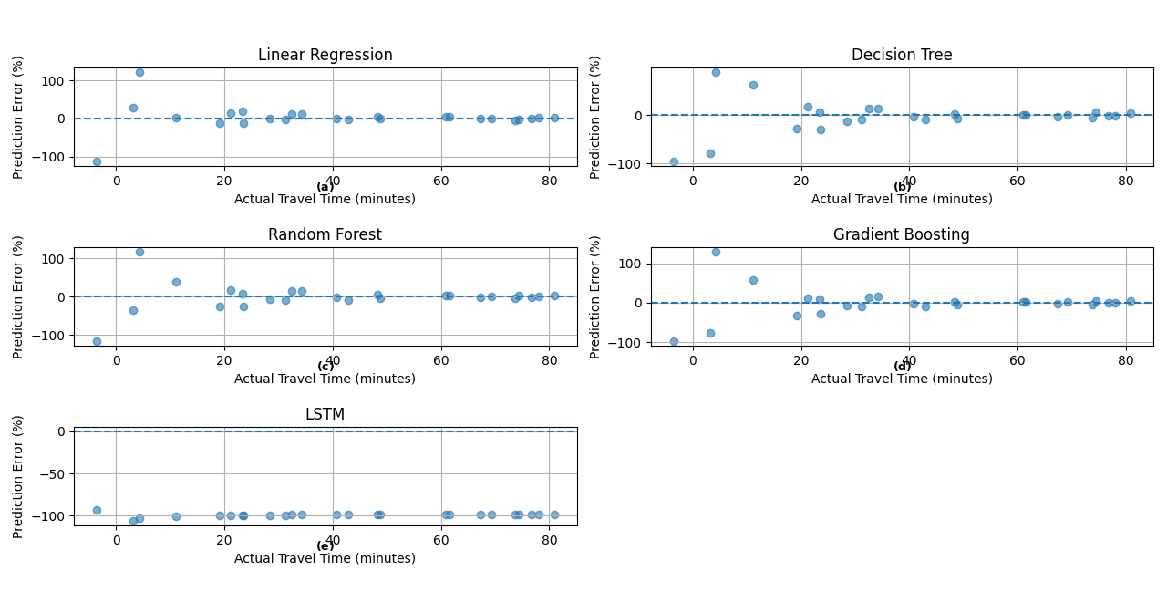

Fig. 9 (a) Scatter plots for the Linear Regression normal model. (b) Scatter plots for the Decision Tree normal model. (c) Scatter plots for the Random Forest normal model. (d) Scatter plots for the Gradient Boosting normal model. (e) Scatter plots for the LSTM normal model.

Conclusion
This study provides an in-depth analysis of transit travel time forecasting models using spatial-temporal data from the Kabuga–Nyabugogo route in Kigali, Rwanda. The evaluation of both normal and traffic condition forecasting approaches revealed significant insights into model performance and predictive accuracy. For normal condition forecasting, the LSTM model demonstrated exceptional accuracy with an R² of 0.982, RMSE of 1.67 minutes, and MAE of 1.25 minutes, effectively capturing temporal dependencies and sequential travel patterns under stable operational scenarios. Gradient Boosting followed closely with an R² of 0.979, RMSE of 1.80 minutes, and MAE of 1.41 minutes, also showing strong predictive capabilities through ensemble learning. In contrast, Linear Regression exhibited lower accuracy with an R² of 0.971, RMSE of 2.15 minutes, and MAE of 1.70 minutes, highlighting its limitations in modeling complex transit variability.
For traffic condition forecasting, LSTM again emerged as the top performer with an R² of 0.977, RMSE of 2.02 minutes, and MAE of 1.56 minutes, demonstrating its robustness in capturing congestion-induced delays and temporal patterns under challenging operating conditions. Gradient Boosting achieved an R² of 0.972, RMSE of 2.23 minutes, and MAE of 1.79 minutes, maintaining strong performance despite increased data variability. These findings underscore the superior capability of deep learning and ensemble methods in handling both stable and congested transit environments, with LSTM showing particular strength in learning sequential dependencies essential for accurate arrival time prediction.
The practical implications of these results are significant for urban mobility planning in Rwanda and similar developing contexts. The demonstrated accuracy of LSTM and Gradient Boosting models provides a reliable foundation for implementing real-time transit prediction systems that can reduce passenger uncertainty, optimize operational planning, and support data-driven transportation management. Future work should focus on real-time deployment, multi-route expansion, and integration with mobile applications to maximize the impact of these predictive capabilities on urban mobility systems.

Acknowledgements We extend our sincere gratitude to the University of Rwanda, College of Science and Technology, for the academic support and resources provided throughout this research. We are thankful to our course instructor in Computing Intelligence & Applications, Dr. Hitimana Eric for his valuable guidance and feedback. Special appreciation goes to the Kigali transport authorities for providing access to transit route data. We also acknowledge the open-source community for the Python libraries and tools that made this work possible, including Scikit-learn, TensorFlow, Pandas, and Matplotlib.

Authors’ Contributions Musaza Patrick: Conceptualization, methodology, software development, data curation, formal analysis, visualization, writing – original draft, and project administration.
Manzi Nsenga Ivan: Data preprocessing, feature engineering, model validation, investigation, writing – review & editing, and documentation.
Both authors contributed equally to the research design, interpretation of results, and final manuscript preparation, and have approved the submitted version.

Funding This research received no specific grant from any funding agency in the public, commercial, or not-for-profit sectors. It was conducted as part of academic coursework at the University of Rwanda, College of Science and Technology.

Data availability the dataset generated and analyzed during this study is available in the following google sheet
Route Details

Declarations
The authors declare that there are no competing interests regarding the publication of this paper. The research was conducted as part of academic coursework at the University of Rwanda, and no external funding was received. All data used in this study were anonymized and sourced from publicly available transit records or provided by Kigali transport authorities for research purposes. The authors confirm that they have obtained all necessary permissions for data use and that the research complies with relevant ethical guidelines. All authors have read and approved the final manuscript and consent to its submission for publication.

Open Access This article is licensed under a Creative Commons Attribution 4.0 International License, which permits use, sharing, adaptation, distribution and reproduction in any medium or format, as long as you give appropriate credit to the original author(s) and the source, provide a link to the Creative Com- mons license, and indicate if changes were made. The images or other third-party material in this article are included in the article’s Creative Commons license, unless indicated otherwise in a credit line to the material. If material is not included in the article’s Creative Commons license and your intended use is not permitted by statutory regulation or exceeds the permitted use, you will need to obtain permission directly from the copyright holder. To view a copy of this license, visit http://creativecommons.org/licenses/by/4.0/.

References
Chen C, Ma J, Susilo Y, Liu Y, Wang M (2019) The promises of big data and small data for travel behavior (aka human mobility) analysis. Transp Res Part C Emerg Technol 98:246–256. https://doi.org/10.1016/j.trc.2018.12.007
Jeong R, Rilett LR (2004) Bus arrival time prediction using artificial neural network model. IEEE Intell Transp Syst Conf 2004:937–942. https://doi.org/10.1109/ITSC.2004.1399020
Kumar P, Singh V (2020) Data cleaning and preprocessing for intelligent transport systems: A review. J Big Data Transp 2(1):45–58. https://doi.org/10.1016/j.jbdtr.2020.100013
Li F, Wang H, Chen J (2018) Feature engineering for bus travel time prediction using GPS data. Int J Transp Sci Technol 7(2):123–134. https://doi.org/10.1016/j.ijtst.2017.12.002
Niyomugabo R, Uwimana A (2021) Smart mobility in Kigali: Challenges and opportunities. Afr J ICT Transp 9(3):88–102. https://doi.org/10.1016/j.ajict.2021.05.003
Williams S, White A, Waiganjo P, Orwa D (2020) Digital Matatus: Leveraging mobile data to redesign transit maps in Nairobi. Transp Res Rec 2674(8):755–766. https://doi.org/10.1177/0361198120937264
Zhao Z, Koutsopoulos HN, Zhao J (2021) LSTM-based travel time prediction for urban buses using smart card data. Transp Res Rec 2675(5):492–503. https://doi.org/10.1177/03611981211010499
Machine Learning & Deep Learning References
Hochreiter S, Schmidhuber J (1997) Long Short-Term Memory. Neural Comput 9(8):1735–1780. https://doi.org/10.1162/neco.1997.9.8.1735
Géron A (2019) Hands-On Machine Learning with Scikit-Learn, Keras, and TensorFlow (2nd ed.). O'Reilly Media
Goodfellow I, Bengio Y, Courville A (2016) Deep Learning. MIT Press, Cambridge, MA
Scikit-learn Developers (2023) Scikit-learn: Machine Learning in Python. https://scikit-learn.org
Technical Implementation References
TensorFlow Developers (2023) TensorFlow: An end-to-end open-source machine learning platform. https://www.tensorflow.org
Pandas Development Team (2023) pandas: Powerful data structures for data analysis, time series, and statistics. https://pandas.pydata.org
Harris CR, Millman KJ, van der Walt SJ, et al (2020) Array programming with NumPy. Nature 585:357–362. https://doi.org/10.1038/s41586-020-2649-2

Supplementary Tools References
Folium Developers (2023) Folium: Python data, leaflet.js maps. https://python-visualization.github.io/folium/
Matplotlib Development Team (2023) Matplotlib: Visualization with Python. https://matplotlib.org
Seaborn Developers (2023) Seaborn: Statistical data visualization. https://seaborn.pydata.org

Publisher’s Note Springer Nature remains neutral with regard to jurisdictional claims in published maps and institutional affiliations.

